Assignment - 3

Python Programming

|  |  |
| --- | --- |
| Assignment Date | 4 October 2022 |
| Student Name | Hansika N |
| Student Roll Number | CITC1907012 |
| Maximum Marks | 2 Marks |

Problem Statement: Abalone Age Prediction

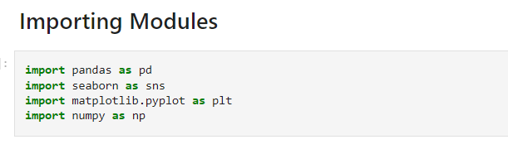

1. Dataset Download

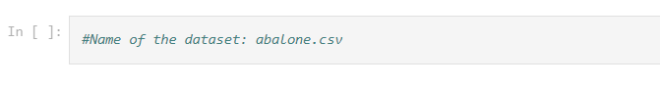

1. Loading the Dataset into the tool

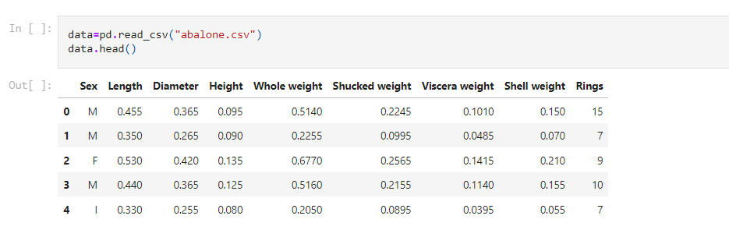

Shape of data:

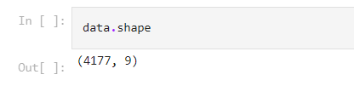

### Adding ‘Age’ into ‘Rings’ - adding '1.5' to the ring data

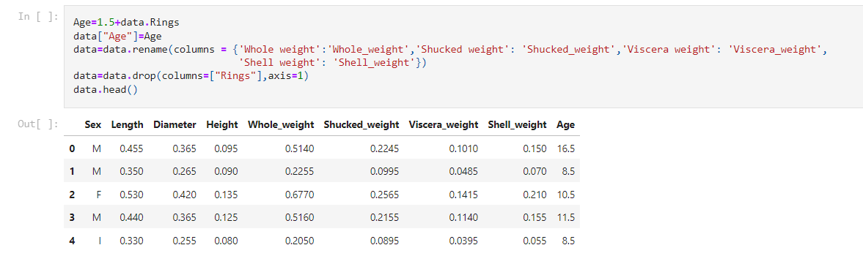

1. Perform below visualizations:

(i)Univariate Analysis

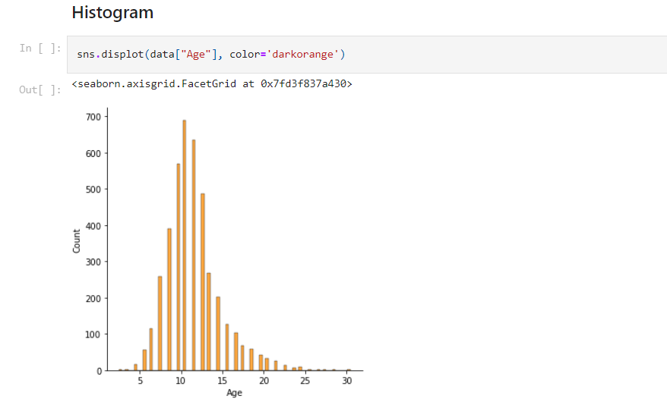

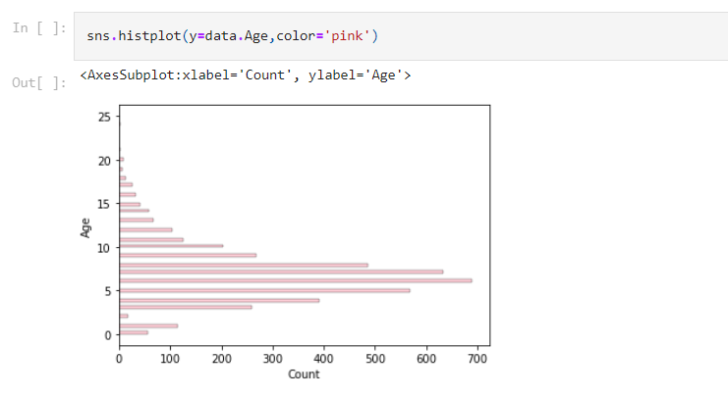

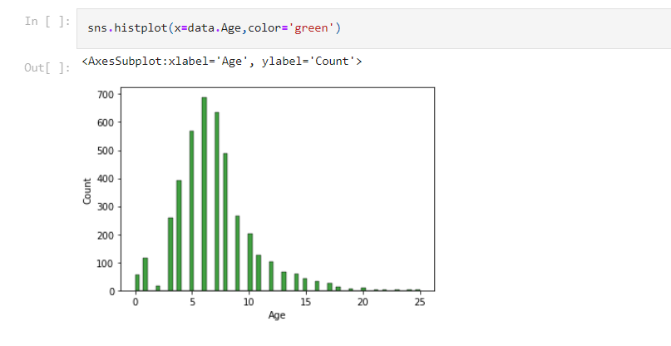

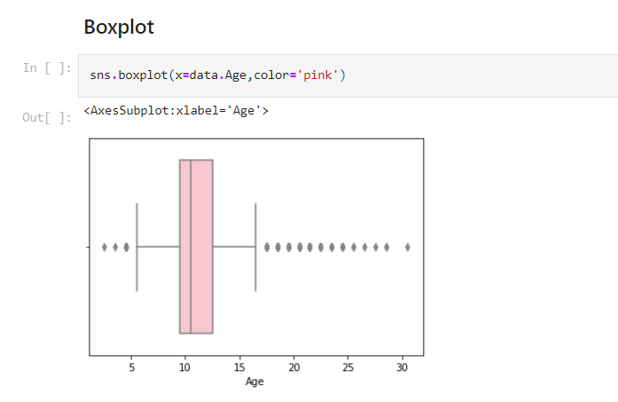

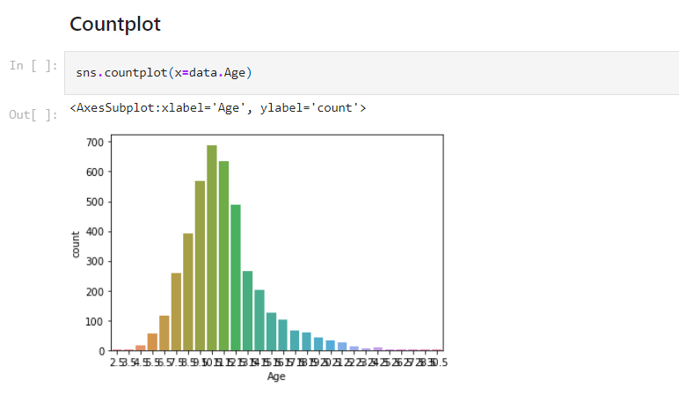

(ii) Bi-Variate Analysis

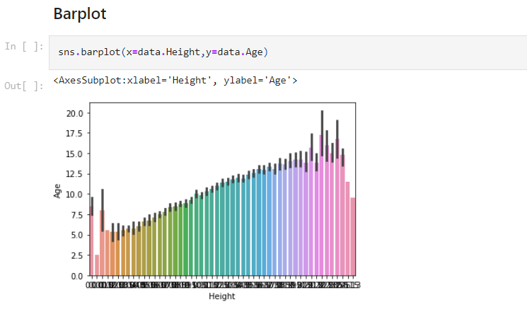

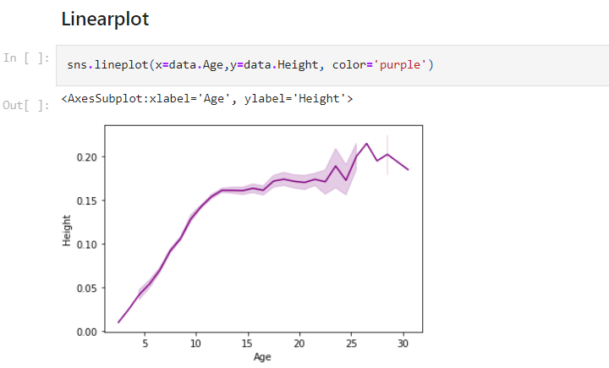

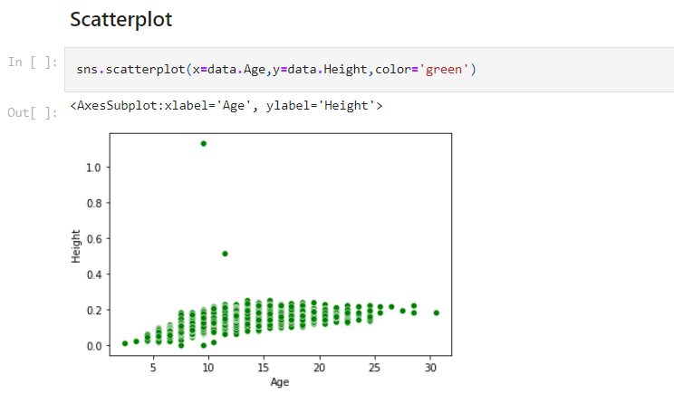

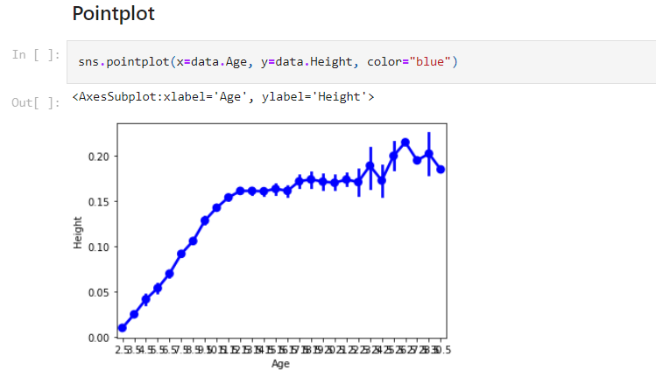

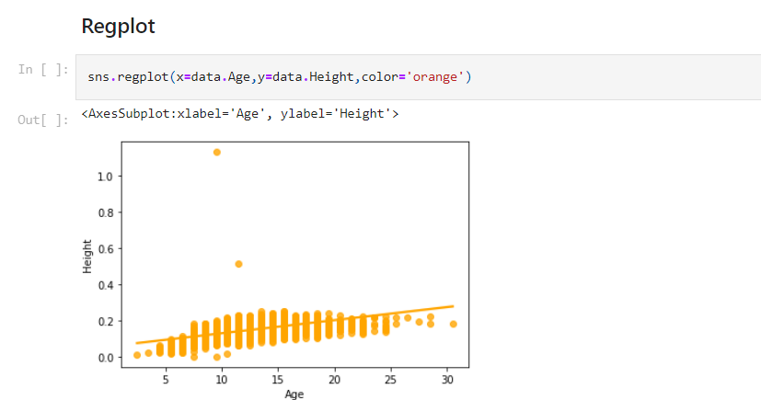

(iii) Multi-Variate Analysis

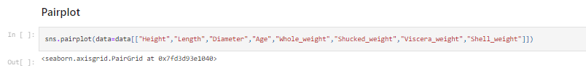

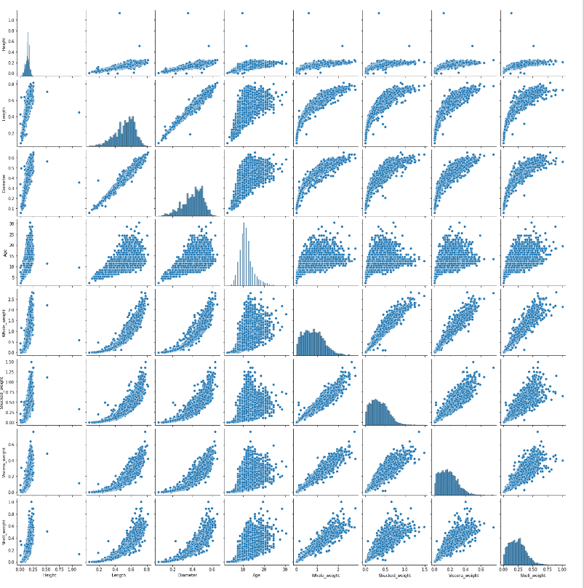



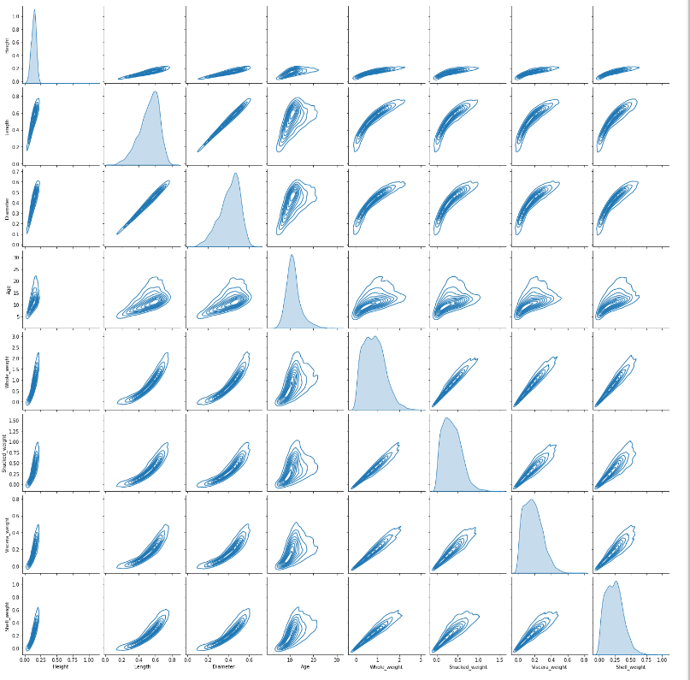

1. Perform descriptive statistics on the dataset

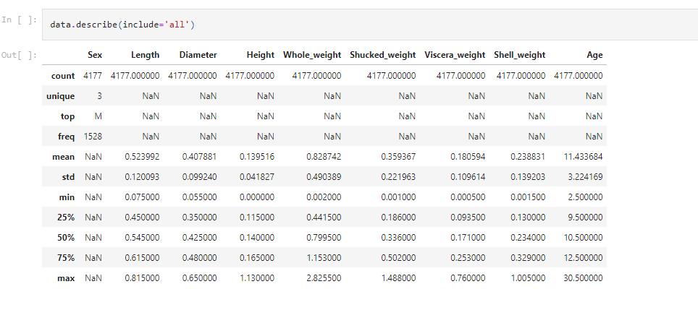

1. Check for Missing values and deal with them

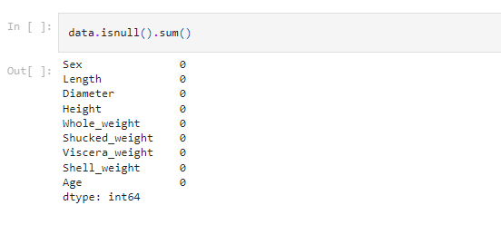

1. Find the outliers and replace them outliers

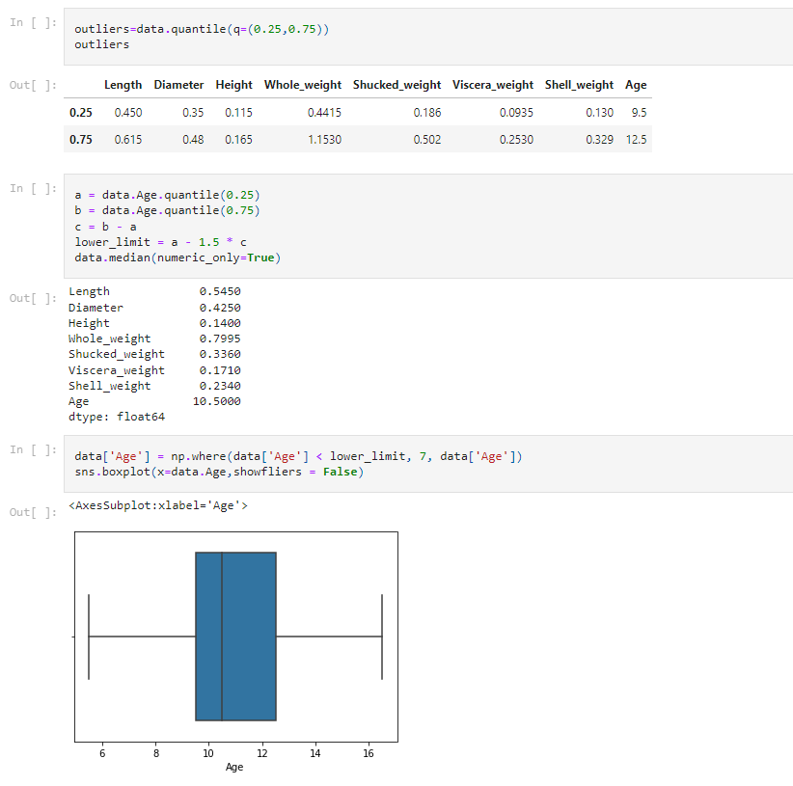

1. Check for Categorical columns and perform encoding

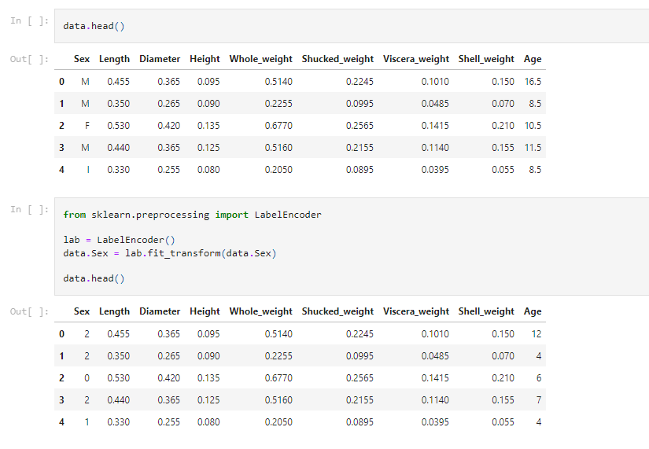

1. Split the data into dependent and independent variables

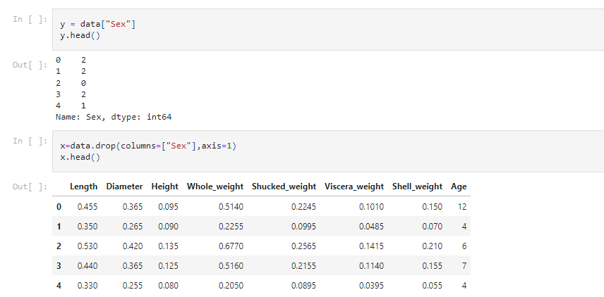

1. Scale the independent variables

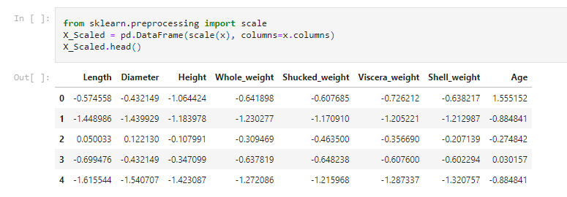

1. Split the data into training and testing

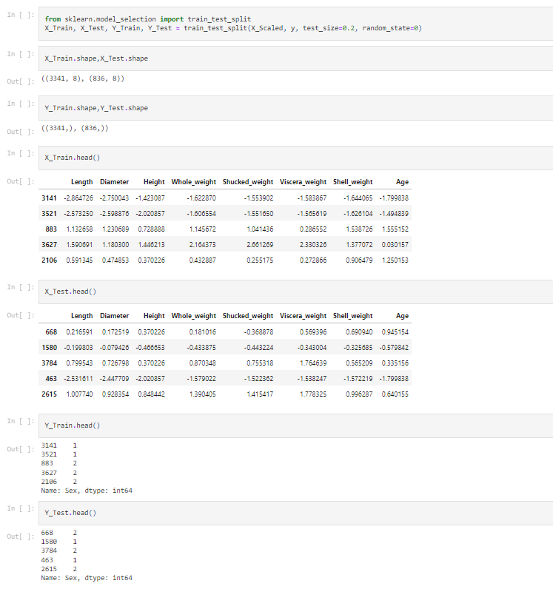

## Build the Model

## 

## Train the Model

## 

## Test the Model

## 

## Measure the performance using Metrics

## 